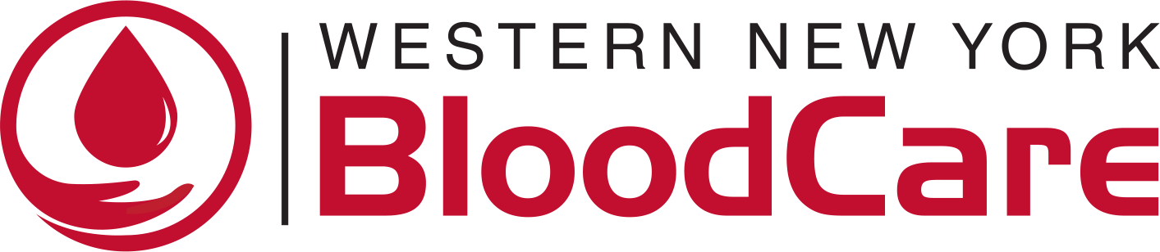
DISCOVERY AND INNOVATION AWARD

Frequently Asked Questions

Q: Is there an LOI (Letter of Interest) required prior to submitting my full application?
A: Yes. Letter of Intent (LOI) Guidelines: A Letter of Intent is required in advance of full application submission and must include the following:
- Primary Investigator’s name, title, position, and institution
- Lay Summary (75 words)
- Abstract summary (75 words)
- Abstract (2000 words)
- NIH-style Biosketch of PI
All five documents must be combined into one PDF and emailed to mwiseman@wnybloodcare.org with the subject line: Last name, first name: 2026 Discovery and Innovation Award LOI
The LOI submission deadline is Friday, May 1, 2026, 11:59 pm eastern. *** In fairness to all there will be no exceptions to this deadline. ***

Q: Is the Discovery and Innovation Award available internationally?
A: This Award is only open to candidates conducting research at a U.S.-based not-for-profit institution by the start date of the award.

Q: I am not familiar with the NIH-style biosketch, is there a template I can use?
A: The template for the NIH-style biosketch can be found here: https://grants.nih.gov/grants/forms/biosketch.htm

Q: Something crazy happened! Can I get an extension on the deadline?
A: We are truly sorry for that inconvenience but, no you cannot get an extension on the deadline for ANY reason.

Q: How will I know that my Application was received?
A: Upon emailing your Application, you will receive a confirmation email. Please keep this email for your records. If you do not receive this email within 72 hours of submitting your application (excluding weekend and holidays), please check your spam/junk folder, and if still nothing, contact mwiseman@wnybloodcare.org or leave a message at 716-896-2470 ext. 4031.

Q: When is the start date of the award?
A: January 1, 2027.

Q: Can my figures and graphs be included as appendices to the application?
A: Yes images and figures may be included.

Q: Can the budget include postdoctoral students and graduate students under personnel?
A: Yes. But we only cover salary or stipends, not tuition.

Q: Under personnel in the budget, can fringe benefits be included as well as salary?
A: Yes.

Q: Are indirect costs allowed?
A: The administrative overhead should not exceed 10% of requested funds. The PI salary request should be for less than 5% effort. The funds should not be requested for capital improvement, payment of rents, construction, or paying monthly bills.

Q: Can there be more than one PI?
A: No, but we will allow for Co-Investigator and Collaborators. The award will only be made to one person.

Q: I have a Co-Investigator/Collaborator on my project. Should I have them write a letter of collaboration?
A: You should list them on your application ask them to write a letter of commitment and include their NIH-style biosketch.

Q: Can I include a manuscript with my application that has not yet been accepted for publication?
A: No, you can only include it if it has been accepted for publication but has not yet been published. We will remove manuscripts from your application should they not meet this criteria, so please indicate where the manuscript has been accepted and the anticipated publication date.

Q: Do I need to include IRB/Animal Use Committee approval with my application?
A: No, but if your application is recommended for funding you must provide it prior to the start date of the award.

Q: Is it ok if my letters of reference come in after the deadline?
A: We prefer that the letters arrive by the deadline.

Q: I already have an award, how can I find out about reporting requirements/no-cost extensions/rebudget/other administrative issues?
A: See 4B under Submission Guidelines.

Q: Is the total amount for the Discovery and Innovation Award $150,000 per year for three years, or for up to three years?
A: It is $150,000 a year for three years, with a total of $450,000.

Q: I am beyond the Early Career or Young Investigator stage, am I still eligible to apply?
A: Yes, we welcome applicants at ALL career stages!

Q: Are MD/PhD students eligible?
A: Yes.

Q: Are there citizenship requirements for your programs?
A: There are no citizenship requirements.

Q: Can I apply if I work at an institution housed outside the United States?
A: No.

Q. Will my application be automatically disqualified if I don’t include any Reviewers?
A. No, it is optional, but it is to your advantage to help us have the best qualified scientific advisors on our team.

Q: When is the deadline?
A: May 1, 2026, , 11:59 pm eastern is the LOI Deadline. If your Project is selected to move forward, you will be notified by June 2026. Full applications will be due July 15, 2026, 11:59pm (EST). Notifications should go out by late fall, and the Project start date is January 1, 2027.

Q: Is there a policy on the use of AI?
A: Yes
- Grants and applications are considered confidential. Therefore, WNYBC will not analyze any submissions using any AI tool. We may use AI to summarize reviewer comments; however, individual grants will not be put into any AI models.
- All submission reviews and readings will be done by WNYBC staff and peer reviewers.
- AI is a public forum, and your ideas are not confidential if using AI. Please enter any proprietary or confidential information into AI tools with caution and in compliance with your institution’s privacy rules. It is recommended to turn off settings “sharing” or “adding to the model” to avoid disclosing confidential information.
- The accuracy of submissions and legal ownership of Intellectual Property (IP) are the responsibility of the applicant. Applicants must ensure they own the rights to all IP they have disclosed in AI.

Q: I won the Award! Will I receive a W-2 or some type of tax document to use when I file my taxes?
A: We do not provide any documentation for tax filing. You should check with the IRS or your tax-preparer to determine the best way to declare the Award.

Q: Can I apply again if I have already won this award?
A: Yes

Q: Can I resubmit my original project that won the Award?
A: Yes – IF your project has evolved. You must include a dedicated section of how the previous funding supported the development for your new proposal, and how the new project seeks to further advance the preliminary findings

