Wayback Machine

1. Google Wayback machine or go to <https://web.archive.org/>
2. Enter a URL- for this I will use the URL to an RFP that has been pulled and no longer exists:

<https://grants.nih.gov/grants/guide/pa-files/PAR-24-320.html>

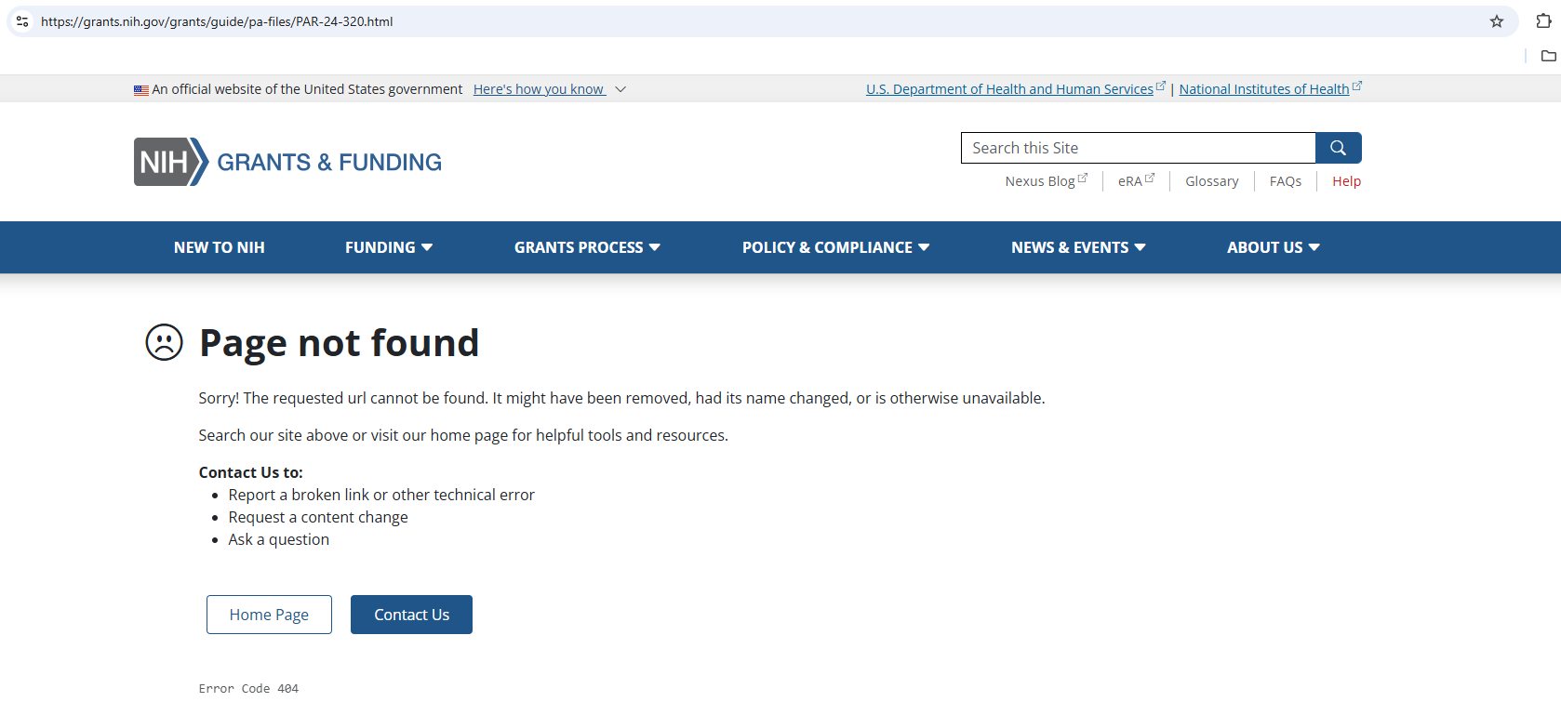

1. Enter this URL into the Wayback Machine search engine.

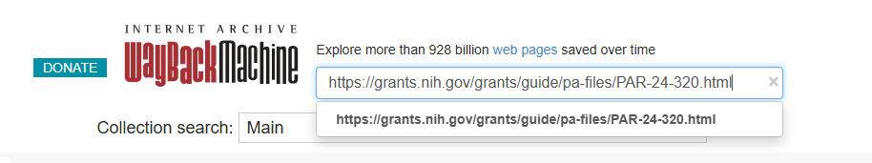

1. You will be taken to a timeline/calendar.

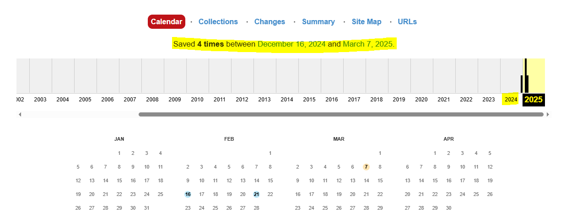

1. Pick a date that you want to go back to. I must be 1 of the dates that has a highlighted circle indicating that it’s one of the “saved 4 times between December 16, 2024 and March 7, 2025” I picked a date before the inauguration- instead of 2025, click on 2024. You will see that it was saved on Dec 16, 2024

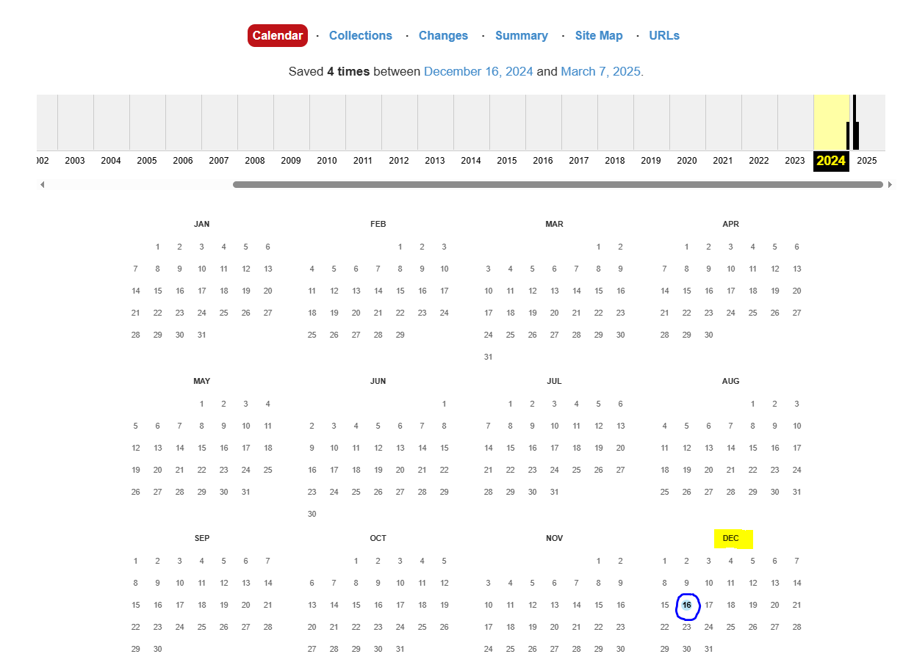

1. Click on the date that you want to go back to

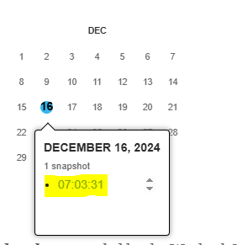

1. The wayback machine will take to you the URL that it saved on the chosen date/time

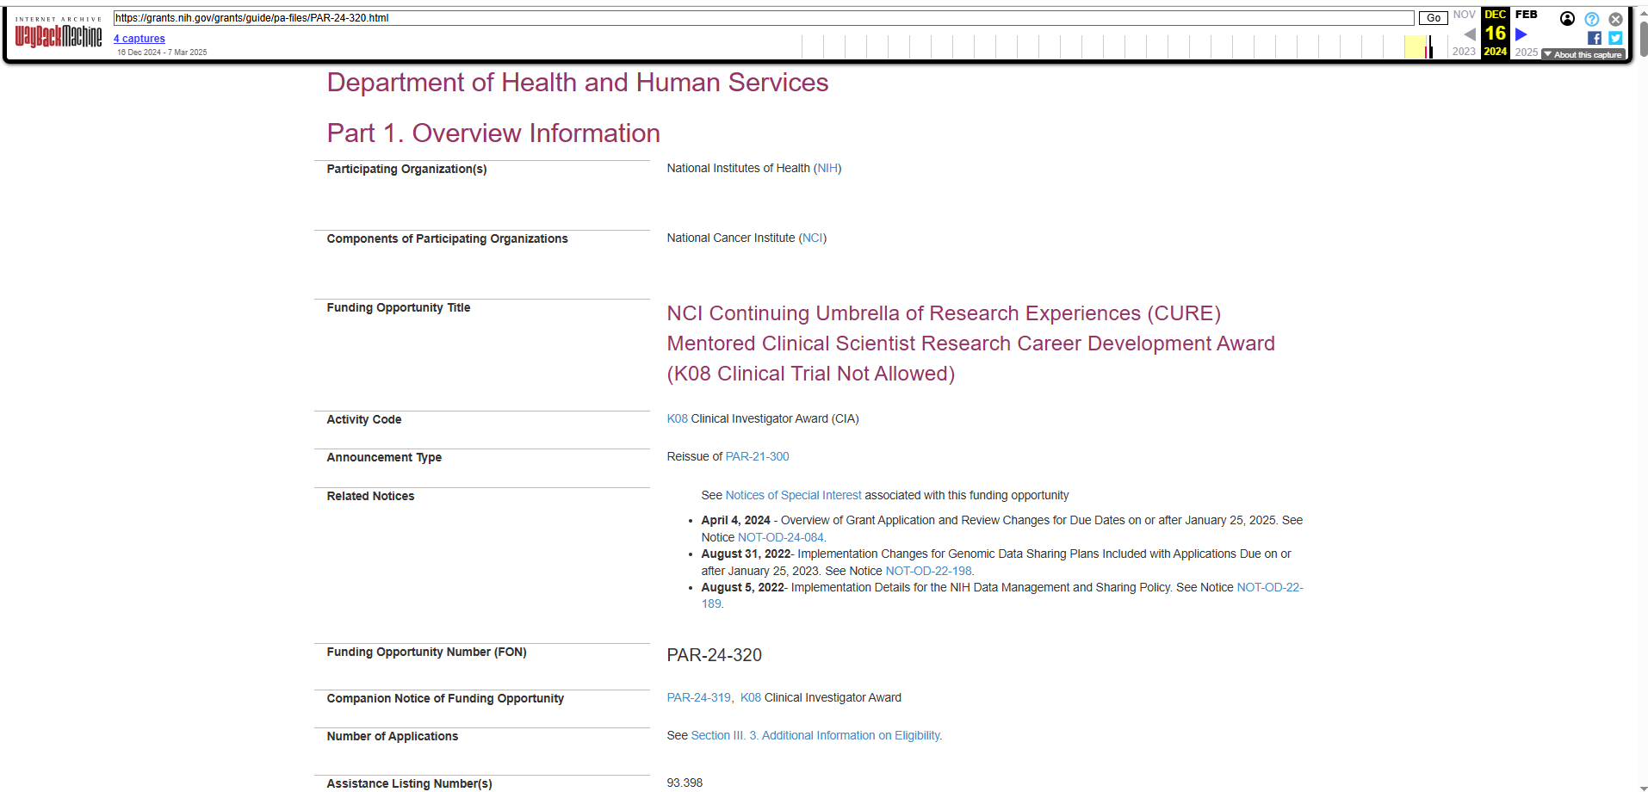

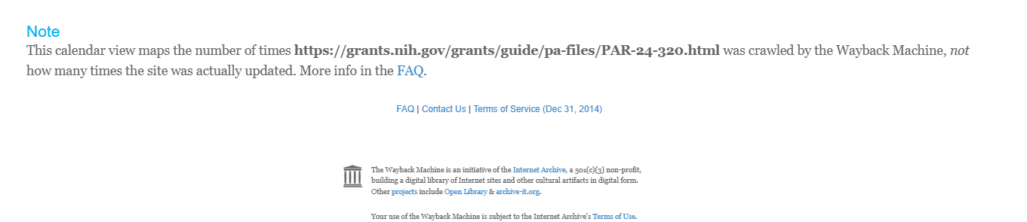NOTE