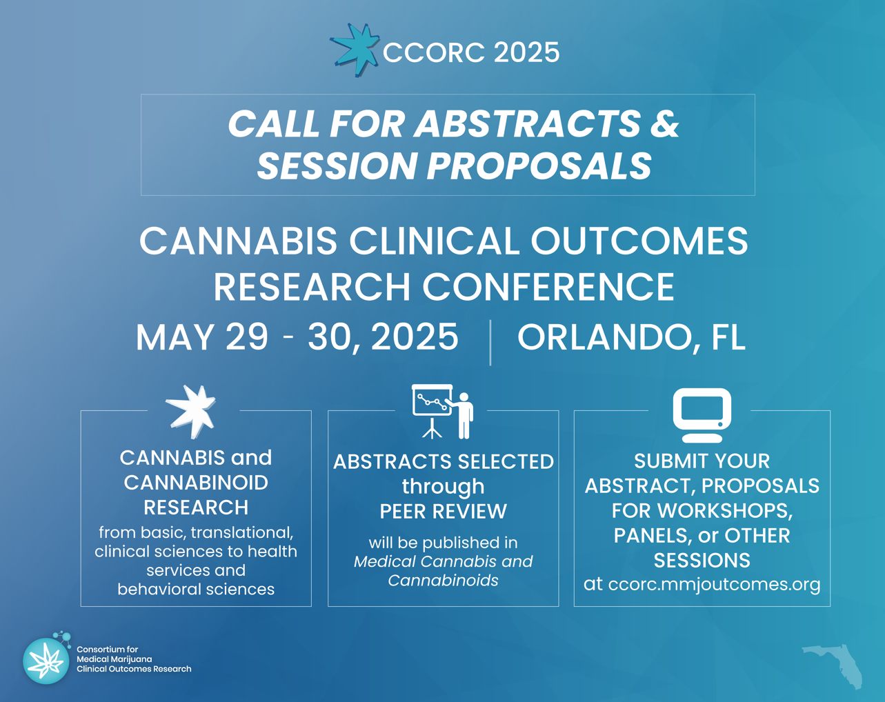

CCORC 2025: Call for Abstracts and Session Proposals

SUBMISSION DEADLINE: FEBRUARY 19, 2025, 11:59 PM EST

The Consortium for Medical Marijuana Clinical Outcomes Research is now accepting abstracts and session proposal submissions for the fifth annual Cannabis Clinical Outcomes Research Conference (CCORC) on May 29-30, 2025.

All submissions will be peer-reviewed and top abstracts will be invited for oral presentations. All abstracts accepted by the conference will be published in Medical Cannabis and Cannabinoids.

Abstracts and posters submitted by students will be considered for awards presented on the final day of the conference. Student presenters from Consortium member universities are eligible to apply for travel support.

Please reach out to mmj.outcomes@cop.ufl.edu with any questions.

Learn more >

