**SETTING UP DELEGATION AUTHORITY IN SciENcv**

**PI INSTRUCTIONS**

*SciENcv is a free service offered by NIH’s NCBI for generating biosketches and current & pending support lists in the required NIH and NSF formats.*

You can grant delegate access to your NCBI account, allowing full access to create and revise their documents.

## ***Creating your own NCBI account***

1. Go to *ncbi.nlm.nih.gov* and click the *Sign in to NCBI* link in the upper right corner.

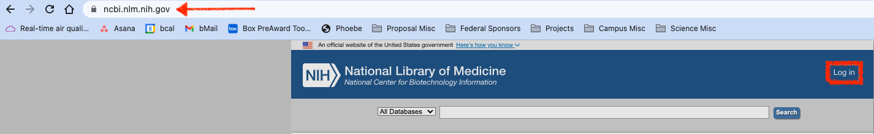

1. 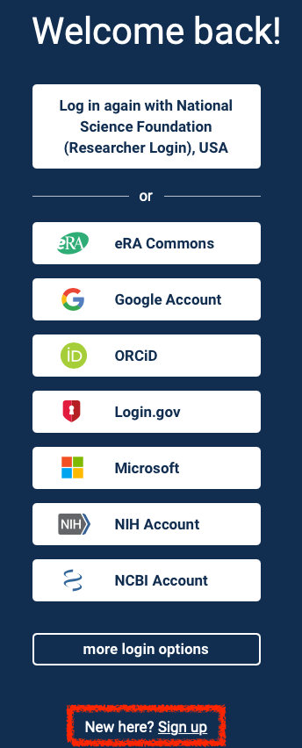Click on *other login options*. Then scroll down to the end of the options and click on *New here? Sign up*.

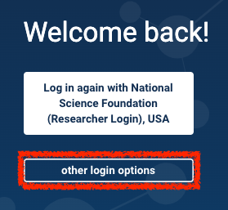

1. Select with third-party log-in you’d like to use and follow the prompts to complete account set-up.

## ***Setting up delegation authority***

1. Log in to your NCBI account and then click on the account email in the upper right corner. (The PI’s identity has been greyed out in this example.)

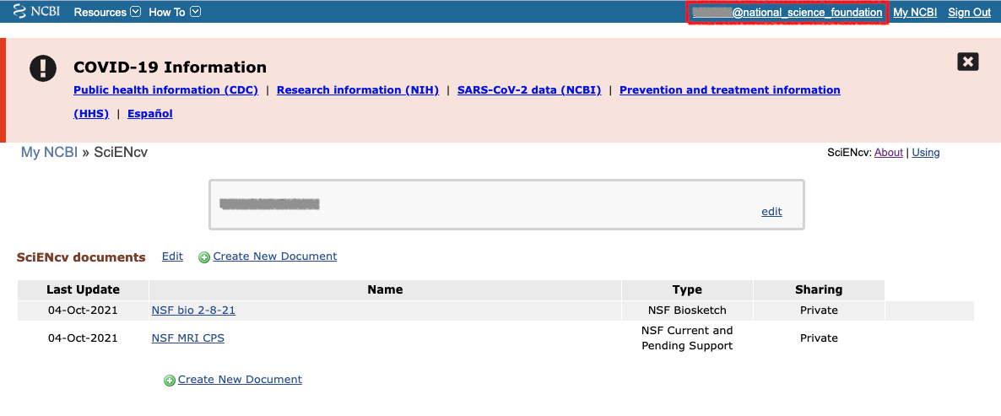

Scroll down to the *Delegates* box and click on the *Add a Delegate* link.

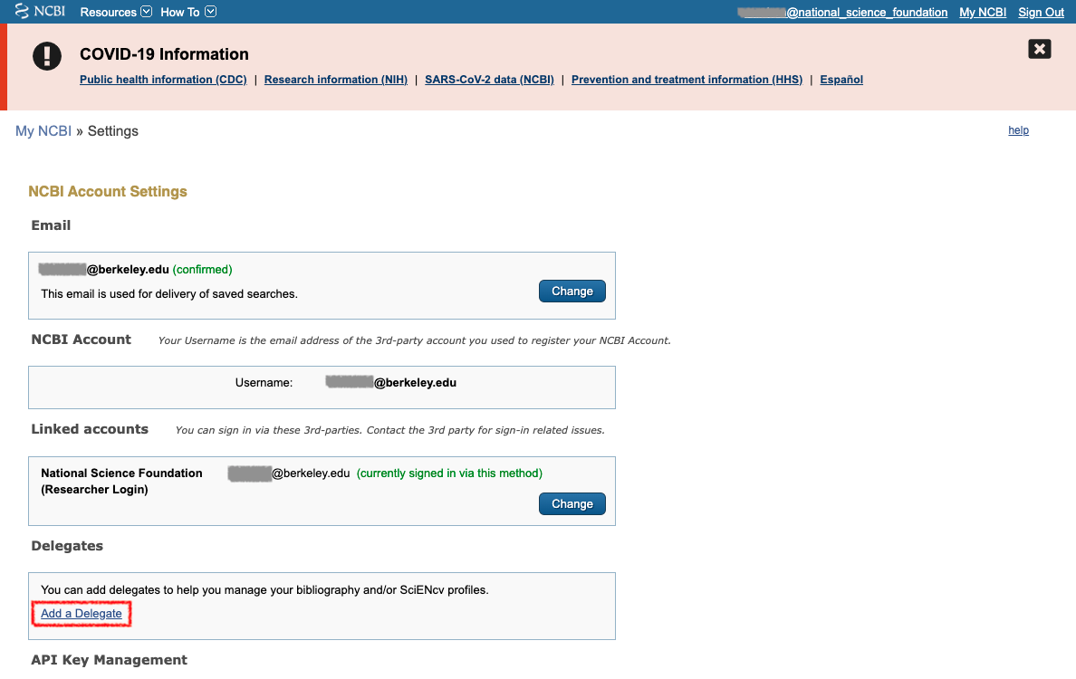

1. Enter Kris’ email (*kstangl@berkeley.edu*) and click the *ok* button.

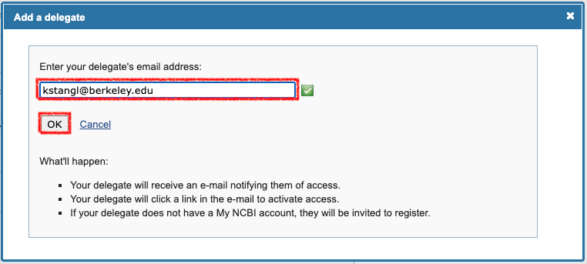

1. This will trigger an automatic email to Kris. Their email will now appear as *awaiting confirmation* in the *Delegates* box. They will receive an email inviting them to accept delegation responsibility.

