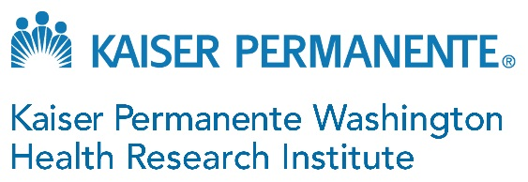

Recruitment Notice: Senior Manager, Post-Award Grants Accounting

Serve your community and the nation by leading the Post-Award Grants Accounting Team in the Grants & Contracts Administration Business unit at Kaiser Permanente Washington Health Research Institute, a public interest organization embedded in one of the nation’s premiere integrated health systems.

The person in this new Washington State-based position will collaborate with leading health scientists and administrative personnel to provide administrative management and direction for research that aims to improve the health, well-being, and health equity for our Kaiser Permanente members and all communities through collaborative research and evaluation. We’re looking for a dedicated and innovative leader who is excited to join a workforce that values diversity and working with people from a broad range of backgrounds.
Essential responsibilities include:
- Leadership and direction of the research institute’s post-award & accounting team, focusing on successful execution of business unit goals and operational plans.
- Communication and collaboration, serving as the primary liaison between the post-award team and the pre-award, contracts, and research finance team withing Grants and Contracts Administration (GCA) as well as other research institute business units and divisions.
- Regulatory compliance, assuring awarded grants are compliant and consistent with all applicable regulations, policies, and procedures.
- Administration and management, providing oversight of post-award team member professional development and performance, assisting the Director of GCA with business unit strategic initiative planning and implementation as well as budget management.
- Developing efficient systems, promoting use of standard work to improve or develop processes in response to regulations or the implementation of systems.

For more information or to apply, go to the following site (job # 1080330):
https://www.kpwashingtonresearch.org/about-us/careers/jobs#dga

You may also contact the KP Recruiter for this position, Miesha.T.Thomas@kp.org for additional information.
Kaiser Permanente is an equal opportunity employer committed to a diverse and inclusive workforce. Applicants will receive consideration for employment without regard to race, color, religion, sex (including pregnancy), age, sexual orientation, national origin, marital status, parental status, ancestry, disability, gender identity, veteran status, genetic information, other distinguishing characteristics of diversity and inclusion, or any other protected status.
External hires must pass a background check/drug screen. Qualified applicants with arrest and/or conviction records will be considered for employment in a manner consistent with federal and state laws, as well as applicable local ordinances, including but not limited to the San Francisco and Los Angeles Fair Chance Ordinances.

