**SciENcv Instructions**

The Office of Contracts and Grants at CU Boulder has pulled together and highlighted information about SciENcv in an effort to assist CU Boulder’s research community. If you have questions or need assistance, please contact your [OCG Proposal Analyst](https://www.colorado.edu/ocg/directory/).

**Full Instructions can be found at:**  <https://www.ncbi.nlm.nih.gov/books/NBK154494/>

Science Experts Network Curriculum Vitae (SciENcv) is a new electronic system that helps researchers assemble the professional information needed for participation in federally funded research. SciENcv gathers and compiles information on expertise, employment, education and professional accomplishments. Researchers can use SciENcv to create and maintain biosketches that are submitted with grant applications and annual reports. SciENcv allows researchers to describe and highlight their scientific contributions in their own words.

**What SciENcv does:**

* Eliminates the need to repeatedly enter biosketch information
* Reduces the administrative burden associated with federal grant submission and reporting requirements
* Provides access to a researcher-claimed data repository with information on expertise, employment, education, and professional accomplishments
* Allows researchers to describe their scientific contributions in their own language

**Who Developed SciENcv**

The SciENcv utility is a cooperative project requested by the [Federal Demonstration Partnership](http://sites.nationalacademies.org/PGA/fdp/index.htm) (FDP), which is an association of academic research institutions and federal agencies. In collaboration with the FDP, SciENcv is being built by the [National Center for Biotechnology Information](https://www.ncbi.nlm.nih.gov/) (NCBI) at the National Institutes of Health under the aegis of an [interagency workgroup](http://rbm.nih.gov/profile_project.htm) composed of members from the Department of Defense, the Department of Energy, the Environmental Protection Agency, the National Institutes of Health, the National Science Foundation (NSF), The Smithsonian, and the United States Department of Agriculture. The interagency workgroup operates under the National Science and Technology Council’s (NSTC) [Research Business Models](http://rbm.nih.gov/) and Science of Science Policy Committees.

**Principles of SciENcv**

* Any researcher may register
* Leverages data from existing systems
* Data are owned by the researcher
* Researcher controls what data are public
* Researcher edits and maintains information
* Researcher provides own data to describe research outcomes
* Researcher has ultimate control over data in biosketch

Reference: <https://www.ncbi.nlm.nih.gov/sciencv/background/>

**Step-by-step Access to SciENcv**

1. If you already have a login for NCBI, start here <https://www.ncbi.nlm.nih.gov/account/>, otherwise, if you need to create an account, start here: <https://www.ncbi.nlm.nih.gov/sciencv/>, and follow the instructions below:

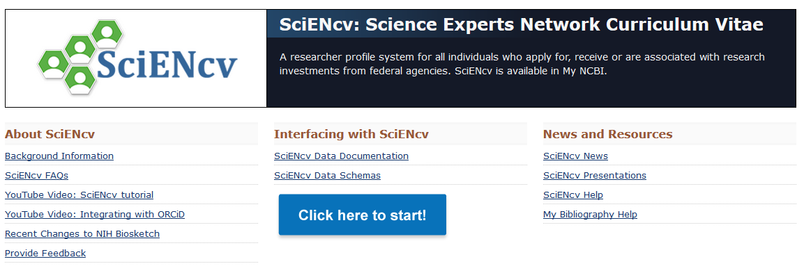

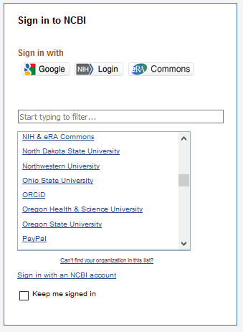

**Choose a login method**. You can also click on the **See more 3rd party sign in options** (not pictured here), scroll down to University of Colorado at Boulder and use your IdentiKey.

If your login method brings you to this landing page, **select MyNCBI**. Otherwise, see the landing page in step 1 of the next section, **Linking Your Accounts.**

1a.

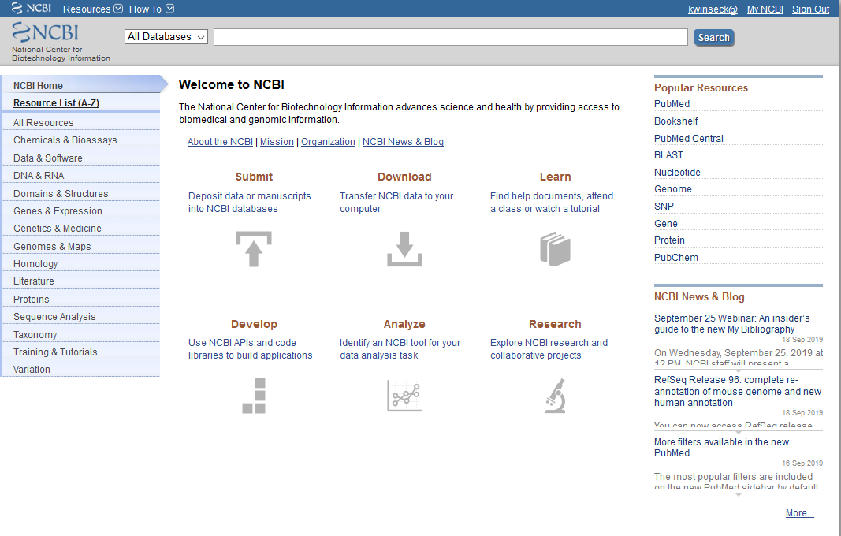

**Linking Your Accounts**

1. Link your accounts by **clicking your user name** in the upper right-hand corner.



1. **Select Change** under linked accounts.

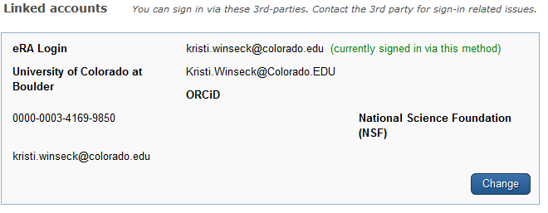

1. **Search** for the account name you’d like to link and then **follow the instructions** on the link.

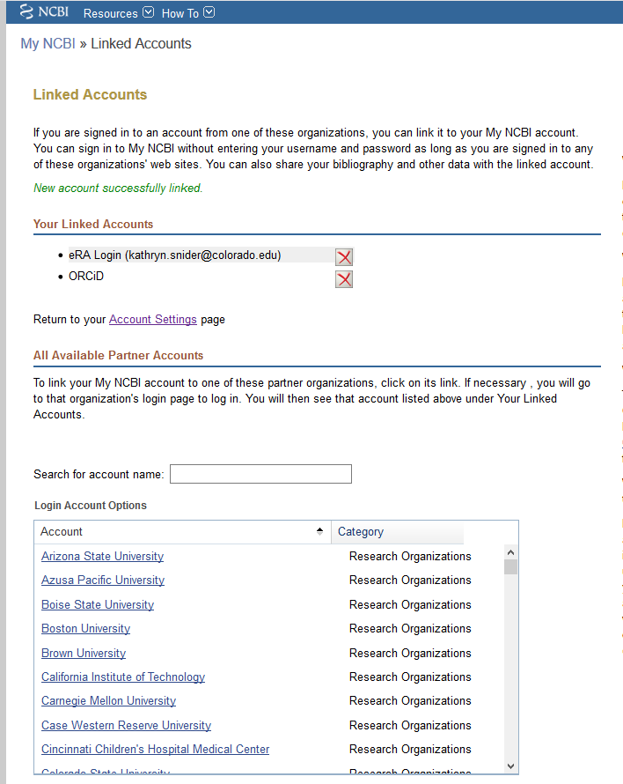 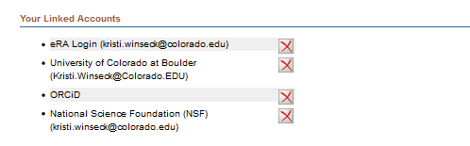

You will be able to see which accounts you’ve linked. **Click on the red X** to unlink accounts.

1. As you link your accounts, you may get messages that look similar to this; make sure you authorize so that the records can “talk” to each other.

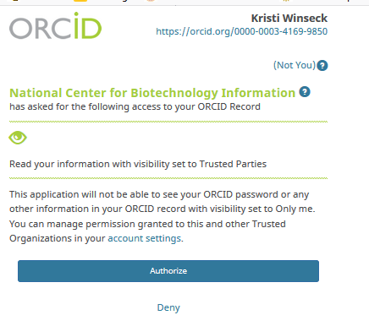

**Building Your Record**

1. If you’ve already built your record, skip to the next section, **Building your Biosketch through SciENcv**.

1. To build your record using your ORCID account, see the next section, **Building your Biosketch through SciENcv** to pull in information from your ORCID – once records are loaded from ORCID, they will also reside in the My Bibliography section.
2. To build your record manually, follow the instructions below:

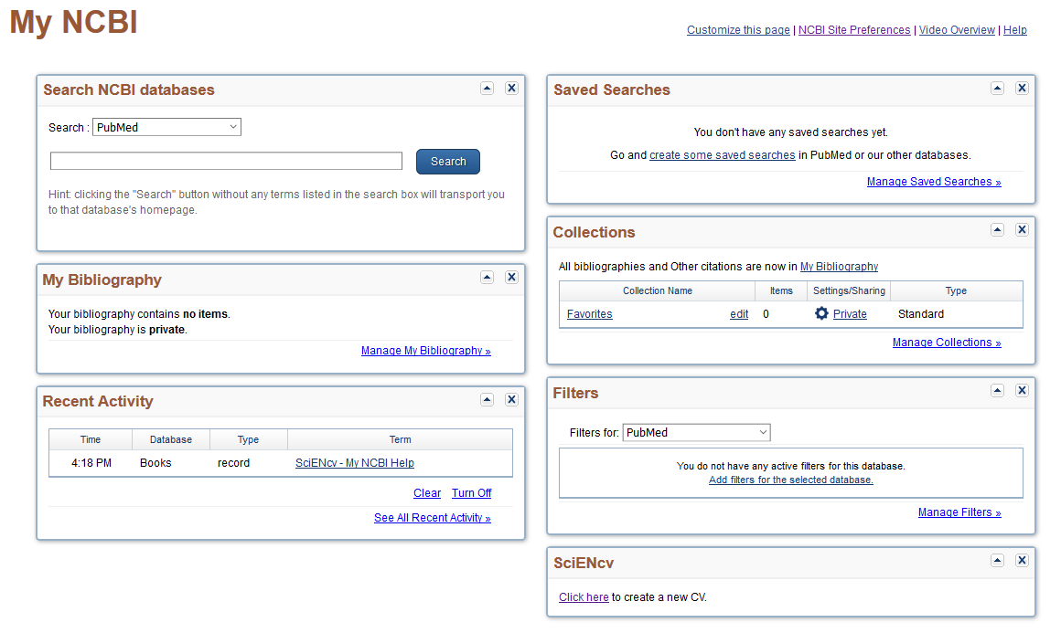

If you choose not to use ORCID to build your SciENcv file, you can build your bibliography through **My Bibliography**.

When **adding from a file,** you can use only .ris, .txt, .nbib

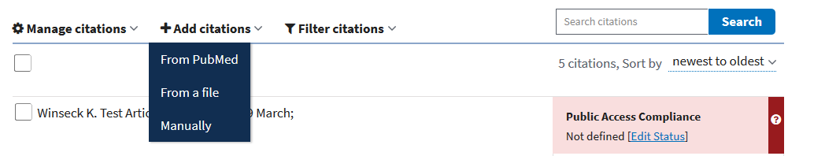

When **adding through PubMed,** you can search by search by topic, title or author.

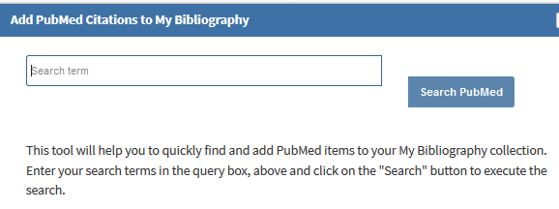

**Building your Biosketch through SciENcv**



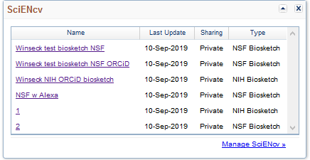

If you don’t have any Biosketches built yet, you will **select Click here**.

**OR**

If you do have Biosketches built, you will **select Manage SciENcv**.

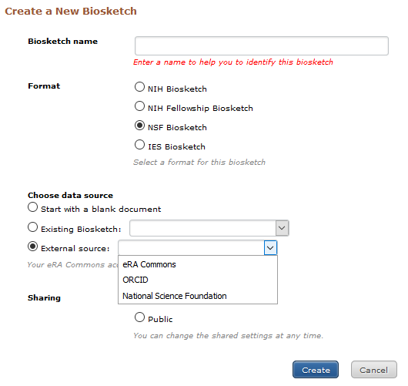

**Choose** the type of Biosketch you need to build, the source of the data**\***, and if it will be public or private.

**\***Note that if you choose an existing biosketch, any existing information that is required in the new biosketch will transfer, for example, personal statements for NIH.

**Select Create**

**BUILD AN NSF BIOSKETCH**

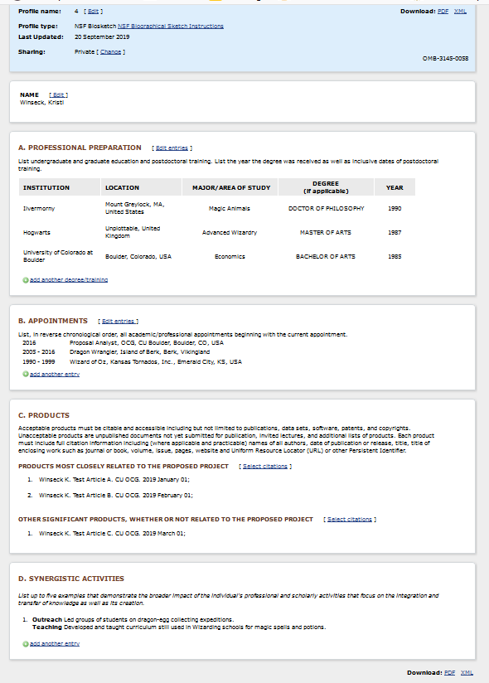

To select products, or choose different ones, choose **Select Citations,** then follow directions in the **Choose My Bibliography** section below.

Unless you copied this from another NSF biosketch, the Synergistic Activities section **must** be **manually entered.** See the Formatting page following the NIH instructions for how to format this section.

Once all of your edits are complete, you can **create a PDF** for upload to the sponsor’s portal.

You can **manually edit** the information in each of these sections.

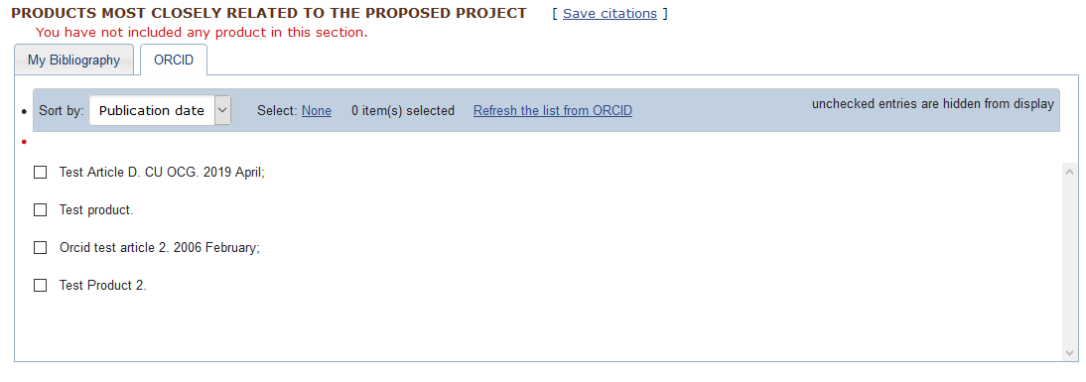

**Choose My Bibliography** for citations stored on this site, or **ORCID to import citations** from ORCID. If you’ve added citations to ORCID since creating this biosketch, **click on Refresh the list from ORCID**.

**BUILD AN NIH BIOSKETCH**

Once all of your edits are complete, you can **create a PDF** for upload to the sponsor’s portal.

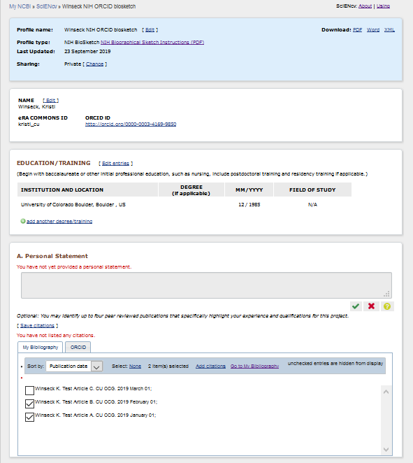 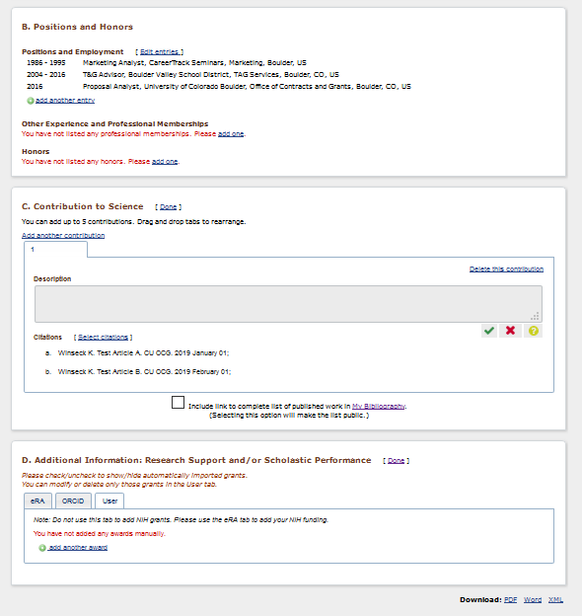

Unless you copied this from another NIH biosketch, the Contributions to Science Description **must be** **manually entered.** See the Formatting page following this page for how to format this section.

Unless you copied this from another NIH biosketch, the Personal Statement section **must be** **manually entered.** See the Formatting page following this page for how to format this section.

**.**

Update this section the same way you do the citation sections. See the instructions in the **NSF biosketch section** above for how to **update and select citations.**

**.**

You can **manually edit** the information in each of these sections.

See the instructions in the **NSF biosketch section** above for how to **update and select citations.**

**.**

**FORMATTING TEXT BOXES IN THE BIOSKETCH**

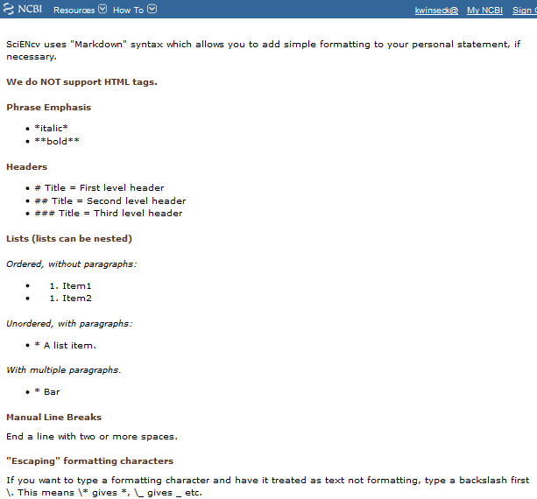

This is true of all text boxes, not just the personal statement.