Step by Step for Identifying You Role in ezFedGrants

- Log into the system using your ID and password
- Your screen should look similar to the one below but will have different tiles across the top and links on the side…BUT, your name should appear at the top right side of the page just as mine does on this screen (see red arrow).
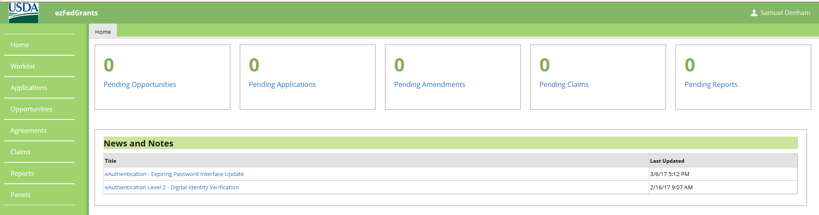

- With your curser, click on your name. A dropdown should appear as below.
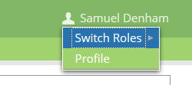

- Hover your curser over the “Switch Roles” button and your current role should appear to the left side of the Switch Roles button as below. You will note that my role is APHIS Grants Specialist. Yours should be either GAO (may say Grants Administrative Officer), Grant Processor, or Signatory Official.

