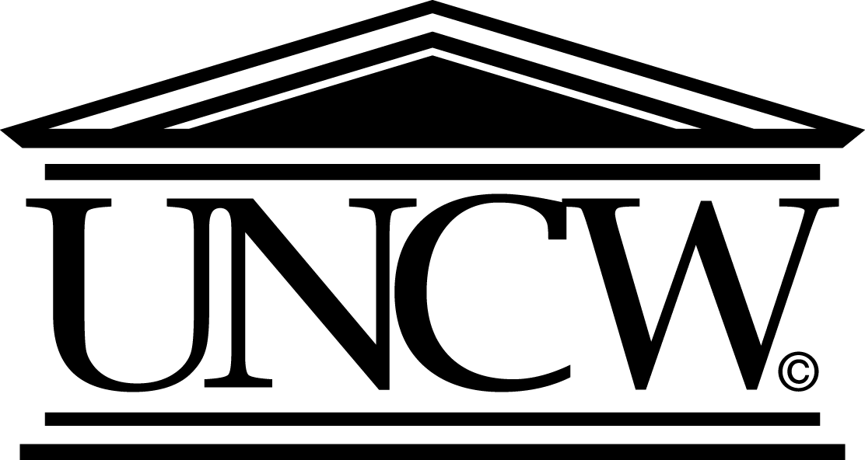

The University Of North Carolina At Wilmington

ASSOCIATE PROVOST FOR RESEARCH
AND DEAN OF THE GRADUATE SCHOOL

The University of North Carolina at Wilmington (UNCW) seeks an accomplished, energetic, and visionary individual to serve as the university’s Associate Provost for Research and Dean of the Graduate School. Reporting directly to the Provost, the individual hired in this recently reconfigured position will be the institution’s chief research officer, overseeing the Office of Research Services and the Graduate School. The preferred starting date is July 1, 2014.

Role of Associate Provost/Dean:

The successful applicant will provide leadership for campus engagement in research, scholarly and creative activity, and graduate education; work with faculty to support and grow research and scholarship at UNCW, including undergraduate and graduate student involvement in those endeavors; oversee millennial (academic and entrepreneurial) campuses and programs; serve as President of the UNCW Research Foundation Board; oversee contract and grant administration and compliance; promote technology transfer; encourage and facilitate the development of new and revised graduate programs; work with faculty and campus administrators and on academic planning and procedures pertaining to graduate education; provide advocacy on graduate academic matters; work to increase graduate enrollments; and assess graduate program performance in collaboration with UNCW’s faculty and academic leadership.

Position Context:

UNCW, the state’s coastal university, is located in historic Wilmington, NC, a vibrant seaport community of more than 100,000 located between the Cape Fear River and the Atlantic Ocean. Founded in 1947, UNC Wilmington is one of the fastest growing institutions in the UNC system and one of the premier comprehensive institutions in the Southeast. The University has 14,000 undergraduate, master’s and doctoral students in four colleges/schools: Arts and Sciences, Business, Education, and Health and Human Services. The park-like central campus is situated on 660 acres that include a rich diversity of coastal pine and natural wetlands.

UNCW’s CREST Research Park, a millennial campus located directly on the Intracoastal Waterway seven miles from central campus, is one of the most advanced biotechnology research centers on the East Coast, featuring the Center for Marine Science, Shellfish Research Hatchery, and the just-completed MARBIONC (Marine Biotechnology in North Carolina) building. These state-of-the-art marine research facilities serve the scholarly and teaching interests of many UNCW faculty, staff and students and provide a venue for partnerships with entrepreneurs, start-up companies and established businesses that focus on biotechnology, analytical and environmental sciences, and early-stage pharmaceutical research and development. UNCW’s newly created Center for Innovation and Entrepreneurship provides a unique venue for technology transfer and creative entrepreneurial activity, housing the university’s Small Business and Technology Development Center, emerging businesses, and the Seahawk Venture Fund.

UNCW’s Graduate School serves approximately 1,500 students enrolled in 11 certificate, 36 master’s and two doctoral programs, with several others in active development. Among the institution’s nationally renowned programs are the M.F.A. in Creative Writing, Ed.D. in Educational Leadership, and Ph.D. in Marine Biology. Faculty and students in several graduate programs have garnered national recognition and awards, and there are significant opportunities for continued program growth, including through online delivery.

Qualifications:

- An earned doctorate or terminal degree from an accredited university
- An academic record of achievement in teaching, scholarship, and service appropriate for appointment in a UNCW academic unit at the rank of full professor with tenure
- A record of progressively responsible and relevant leadership experience in higher education
- Strong organizational, communication and interpersonal skills
- Significant and successful experience in grant writing and extramural funding
- Significant and successful experience in graduate program development and graduate education
- A record that demonstrates support for undergraduate research
- A commitment to shared governance and a consultative leadership style

Preferred Qualifications:

- Significant and successful experience with enrollment and budget management
- A record of achievement in technology development and interaction with private or commercial entities

Application Procedures:

Screening of applications will begin on January 6, 2014 and will continue until the position is filled. A letter of application addressing position qualifications and a current curriculum vitae should be sent via the online application process available on the Web at http://consensus.uncw.edu. Materials should not be emailed or mailed; MS Word or Adobe PDF attachments are strongly preferred. For questions regarding the online application process, contact Jennifer Coombs at 910-962-3196 or coombsj@uncw.edu. Finalists will be contacted for the names, addresses, and e-mail addresses of five professional references. Under North Carolina law, applications and related materials are confidential personnel documents and not subject to public release. UNCW actively fosters a diverse and inclusive working and learning environment and is an equal opportunity employer. Qualified men and women from all racial, ethnic or other minority groups are strongly encouraged to apply.

