NACCA 2012
National Conference on College Cost Accounting
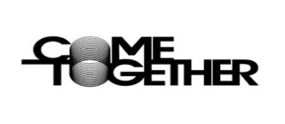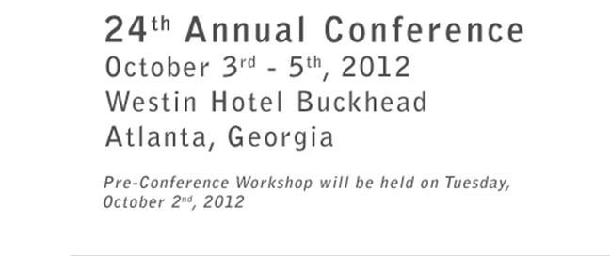
Registration is open reserve your room before our hotel block fills up. Register by August 15, 2012 to take advantage of the Early Bird Rate. Registration closes September 30, 2012.

Program Highlights Include
Federal Representatives
The Division of Cost Allocation will share updates from the DCA
Arif "Mak" Karim, Director, Division of Cost Allocation
Michael Lenonard, A-21 National Specialist

The National Science Foundation will Discuss Fraud Cases and Audit Issues
Paul J. Coleman, CFE, Senior Special Agent Office of Inspector General
Brett Baker, Assistant Inspector General for Audit

COGR representative
David Kennedy, Director, Costing Policy and Studies will update us on the top costing issues being discussed in Washington currently.

University Representatives
Representatives from different Universities will discuss F&A issues, fringe benefits, risk assessment and many other topics.

Also Register for the Pre-conference Workshop on Tuesday October 2nd
Service Center Rate Calculations – Tackling the Challenges’
Come learn more about the accounting for service centers and how they impact the F&A rate, financial statements, departmental budget considerations, etc. The workshop will cover many of the more advanced topics related to service center rate calculations. However, the course material is beneficial to attendees at all levels who want to learn how to address these issues at their institutions.

Visit our new Conference website www.costaccounting.org for details

